Answers:
Section: A
Q2. a. Write the steps involved in K-Means clustering
b. By using Numpy, apply clustering on the given bank dataset, visualize the clusters and provide your interpretation on the clusters
c. Apply the following transformations on the given trinagle.png individually using transformation matrices • Scaling (e.g., double the size • Rotation (e.g., rotate by 45 degrees) • Shearing • Reflection (about x-axis or y-axis) • Translation (use homogeneous coordinates).
Ans:
a. Steps Involved in K-Means Clustering
K-Means is an unsupervised learning algorithm used to group data into K clusters.

- Choose the number of clusters (K)
Decide how many clusters you want to group the data into.
- Initialize the centroids
Randomly pick K points as the initial centroids (cluster centers).
- Assign data points to the nearest centroid
For each data point, calculate the distance to each centroid and assign the point to the nearest one.
- Update centroids
For each cluster, compute the mean of all points assigned to it and update the centroid position.
- Repeat steps 3 and 4
Continue until the centroids no longer change significantly or after a fixed number of iterations.
- Result
Final cluster assignments with minimized within-cluster variance.

b. Clustering on Bank Dataset Using Numpy
(In google collab)

c. Apply Transformations to Triangle Image Using Numpy
(In google collab)

Q4. a. Explain the significance of eigenvalues and eigenvectors in AI applications.
b. Compute the eigenvalues and eigenvectors of the following matrix:
𝐴= [ 4 1
2 3 ]
c. Write the formulas for cosine similarity and Pearson correlation Compute the cosine similarity and Pearson correlation between the vectors “u” and “v”. u=[1,0,1,0] v=[0,1,0,1] Discuss the relationship between cosine similarity and Pearson correlation for the given vectors.
Ans:
a. Significance of Eigenvalues and Eigenvectors in AI Applications
- Dimensionality Reduction (PCA):
In Principal Component Analysis (PCA), eigenvectors represent the directions (principal components) along which data varies the most. The corresponding eigenvalues indicate the amount of variance captured by each component. This helps reduce data dimensionality while retaining essential patterns.
- Feature Extraction:
Eigenvectors can be used to extract features from large datasets, particularly in image processing (e.g., Eigenfaces for face recognition).
- Understanding Linear Transformations:
Eigenvectors describe the directions in which a linear transformation acts by stretching or compressing. This understanding is useful in deep learning, where matrices represent transformations.
- Stability Analysis in Neural Networks:
Eigenvalues are used to analyze the stability of learning algorithms, particularly in optimization problems like gradient descent.
- Spectral Clustering and Graph Applications:
In spectral clustering, the eigenvectors of a graph Laplacian are used to find clusters in data, making it effective for graph-based learning.
- Singular Value Decomposition (SVD):
Used in recommendation systems and NLP (e.g., Latent Semantic Analysis).
- Eigenfaces (Facial Recognition):
Represents faces as linear combinations of eigenvectors derived from a covariance matrix of facial images.
- Google’s PageRank Algorithm:
Computes the importance of web pages using eigenvectors of the link matrix.
b. Compute the Eigenvalues and Eigenvectors of Matrix A
(In google collab)

c. Cosine Similarity and Pearson Correlation
Formulas:
Cosine Similarity:
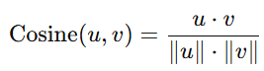
Pearson Correlation:
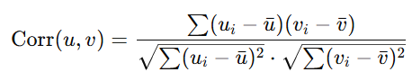

Given Vectors:
u=[1,0,1,0]
v=[0,1,0,1]

Cosine Similarity Calculation
Dot Product:
Magnitudes:
Cosine Similarity:
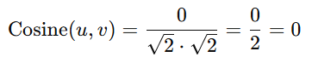

Pearson Correlation Calculation
Means:
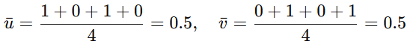
Deviations from Mean:
Numerator:
Denominator:
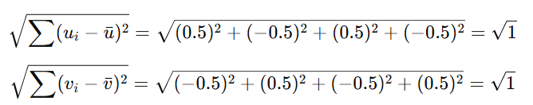
Pearson Correlation:
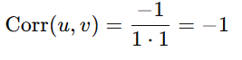

Discussion:
Cosine Similarity = 0.0
This indicates that the two vectors are orthogonal (i.e., they are completely dissimilar in direction).

Pearson Correlation = -1.0
This shows that the two vectors have a perfect negative linear relationship — when one increases, the other decreases symmetrically.

Relationship:
Cosine similarity focuses on the angle between vectors, ignoring magnitude and mean. Pearson correlation adjusts for mean and measures linear relationship. In this case, the vectors are orthogonal (so cosine is 0), and also perfectly negatively correlated (so Pearson is -1).

Q6. a. Compute the least square solution of the equations
2𝑥 + 10𝑦 = 6
4𝑥 − 4𝑦 = 4
2𝑥 − 2𝑦 = −10
b. Prove that if 𝐴=[𝑎1 ⃗⃗⃗⃗ 𝑎2 ⃗⃗⃗⃗ 𝑎3 ⃗⃗⃗⃗ ] is an orthogonal 3×3 matrix, then ||𝑎1 ⃗⃗⃗⃗ +𝑎2 ⃗⃗⃗⃗ +𝑎3 ⃗⃗⃗⃗ ||2=3
c. Solve the following equations by LU Decomposition method.
3𝑥 + 𝑦 - 4𝑧 =0
2𝑥 + 5𝑦 + 6𝑧 = 13
x − 3𝑦 − 8𝑧 = −10
Ans:
a. Least Squares Solution of Overdetermined System
This is an overdetermined system (more equations than variables), so we find the least squares solution to minimize the error.
Step 1:
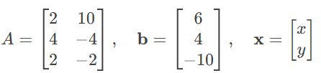
Step 2:
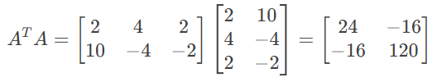
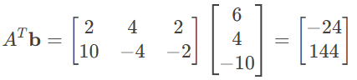

Step 3:
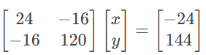
Using Cramer’s Rule or Gaussian Elimination:
x= -1, y= 1.5

b. Proof: A=[a1​a2​a3​] is Orthogonal, then ∥a1​+a2​+a3​∥²=3.

To Prove:
∥a1​+a2​+a3​∥²=3

Proof:
∥a1​+a2​+a3​∥²=(a1​+a2​+a3​)^{T}(a1​+a2​+a3​)

Expanding:
a₁^{T}​ a₁​+ a₂^{T}​ a₂+ a₃^{T} a₃​+2(a₁^{T}​ a₂​+ a₁^{T} a₃​+ a₂^{T}​ a₃)

Since a_{i}​ are orthonormal:
=1+1+1+2(0+0+0) = 3
Hence Proved.

c. Solving the System by LU Decomposition

3x+y−4z​=0
2x+5y+6z=13
x−3y−8z=−10​

In Matrix Form Ax = b
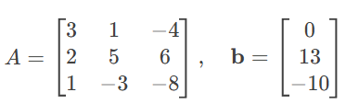
Perform LU Decomposition

We decompose A=LU, where:
L is lower triangular (with 1’s on diagonal).
U is upper triangular.

Using Gaussian Elimination:
1. First Pivot (Row 1):
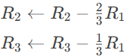

Updated Matrix:
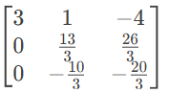

2. Second Pivot (Row 2):
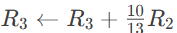

Final U:
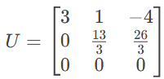

Problem: The last row is all zeros = Singular Matrix
Conclusion: The system is not solvable by LU decomposition (determinant = 0).

Final: The system is singular (no unique solution).

Q8. a. Briefly describe the architecture of an Extreme Learning Machine (ELM). Highlight the role of: • Input weights • Activation function • Closed-form solution for output weights
b. Critically analyze the advantages and limitations of Extreme Learning Machines (ELM) compared to traditional backpropagation-based neural networks.
c. Develop a handwritten digit classification system using Extreme Learning Machines (ELM) on the MNIST dataset using NumPy. from sklearn.datasets import fetch_openml
mnist = fetch_openml('mnist_784', version=1)
X = np.array(mnist.data)
y = np.array(mnist.target, dtype=int)
Ans:
a. Architecture of an Extreme Learning Machine (ELM)
Extreme Learning Machine (ELM) is a type of single hidden-layer feedforward neural network (SLFN) that offers extremely fast training time using a non-iterative approach.

Architecture Overview:
- Input layer → Hidden layer (with randomly assigned weights) → Output layer
Key Components:
- Input Weights:
Weights connecting the input layer to the hidden layer.
Randomly initialized and never updated during training.
These random weights help in projecting the input data into a higher-dimensional space.
- Activation Function:
Nonlinear function applied at the hidden layer.
Common choices include sigmoid, ReLU, or tanh.
Helps introduce non-linearity and learn complex patterns.
- Closed-form solution for Output Weights:
After computing the hidden layer output matrix H, ELM solves the output weights β using a Moore–Penrose pseudoinverse:
β = H†Y
This is a closed-form solution, meaning no iterative training is required (unlike gradient descent).

b. Advantages and Limitations of ELM

Advantages
- Fast training – No backpropagation, weights are computed in one step.
- Simple implementation – Single hidden layer suffices.
- Good generalization – For small-to-medium datasets.
- Works well for classification/regression tasks

Limitations
- Random weights – Performance may vary depending on initialization.
- Not scalable – Performance degrades with very large datasets.
- No feature learning – Lacks deep representation learning like deep networks.
- Not ideal for complex vision or sequence tasks like CNNs or RNNs handle.

ELM is great for speed and simplicity but doesn’t match deep networks in tasks requiring hierarchical feature learning. And we can use for real-time applications where quick training is needed.

c. ELM on MNIST Handwritten Digit Classification using NumPy
(In google collab)

STUDENT UNDERTAKING
I, [Student Full Name], bearing Student ID/Registration Number: [Your ID], hereby declare that:
- All answers provided in this answer script are original and a result of my own understanding.
- I have not engaged in any form of copying, plagiarism, impersonation, or malpractice.
- I understand that any academic dishonesty will lead to disciplinary action as per university regulations.
Signature: Hari Krishnan
Date: 14-Jun-2025

******End******

